Before configuring mail server,
You need to make acl and open port for SMTP(25) and POP3(110) and apply in interface dmz in same make acl for inside network mls0 and mls1 open permit any any or you can make specific rules you want to configure to block anything you want enterning gateway of interface . Necessary acl is already provided in firewall folder check that out.
Now lets first configure static ip for mail server navigate destop and ip configuration and set static.
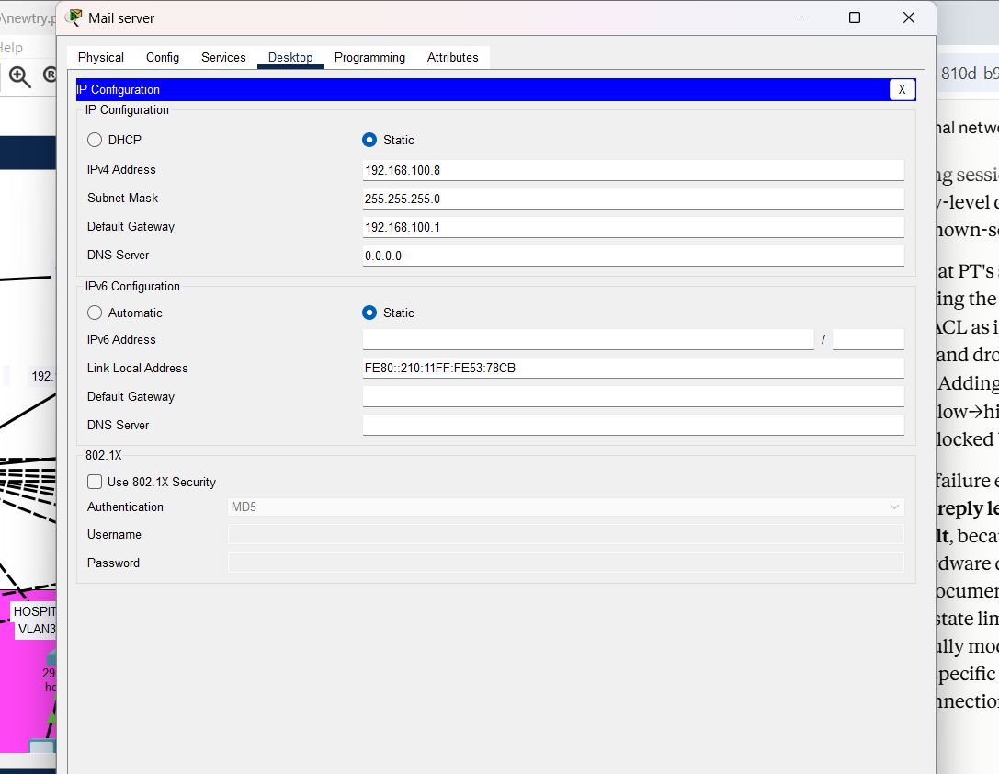
Now navigate to services and turn on mail service
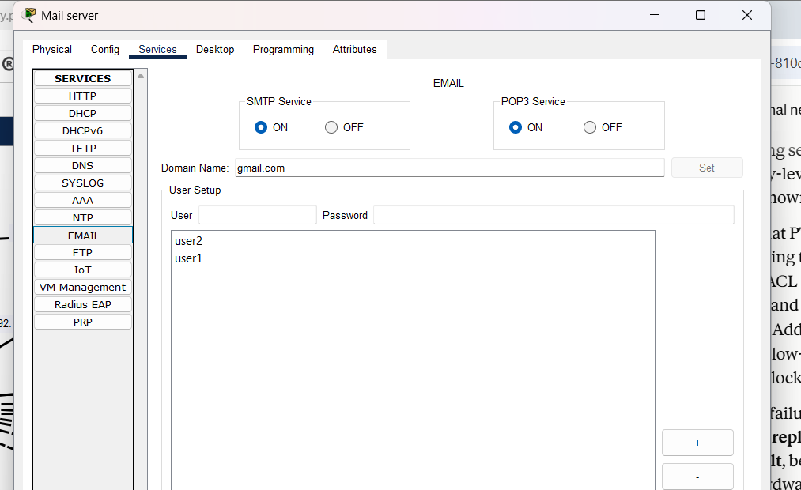
Create domain name and user here,
I used gmail.com because it doesn’t require dns setup for resolving in this packet tracer,
Now login from dmz user1 and send msg to user2
than login from vlan 20 pc and check that msg,
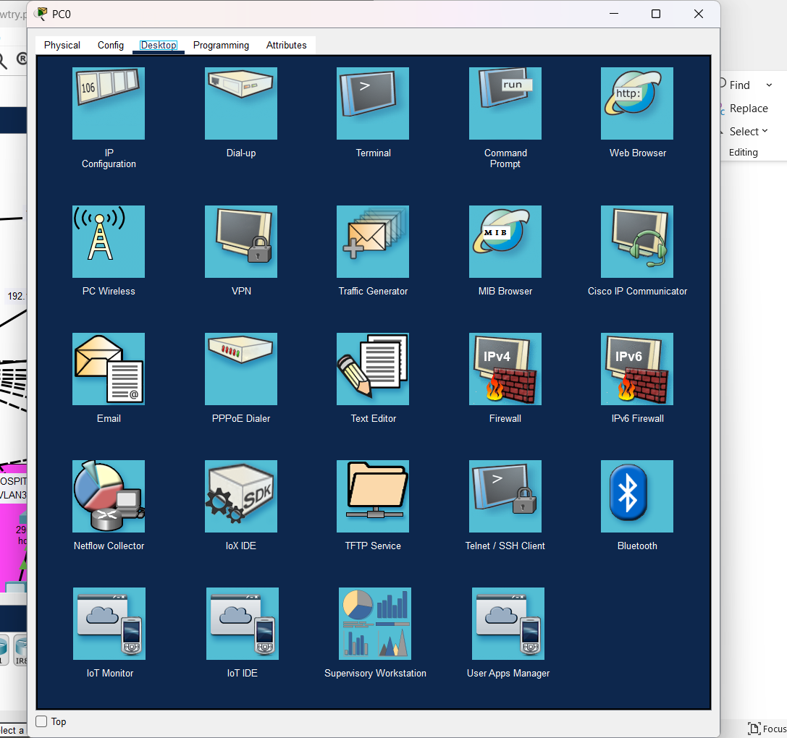
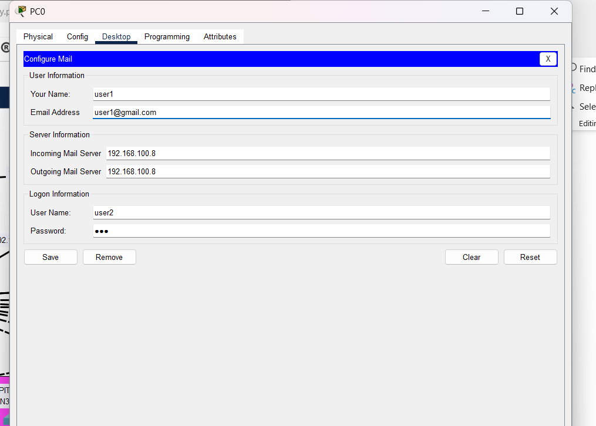
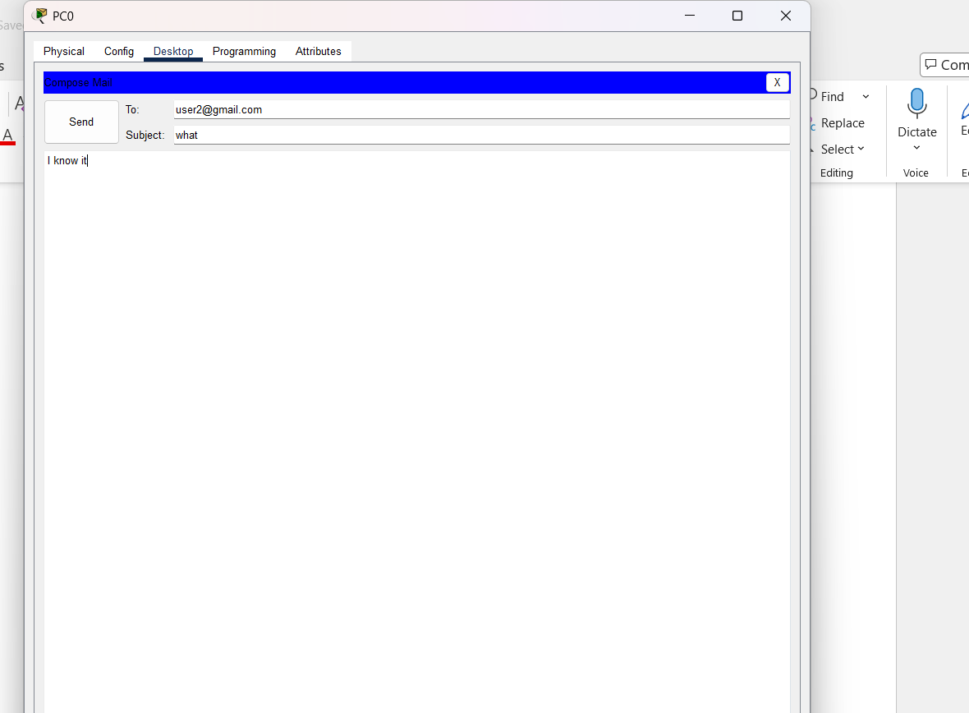
Send,
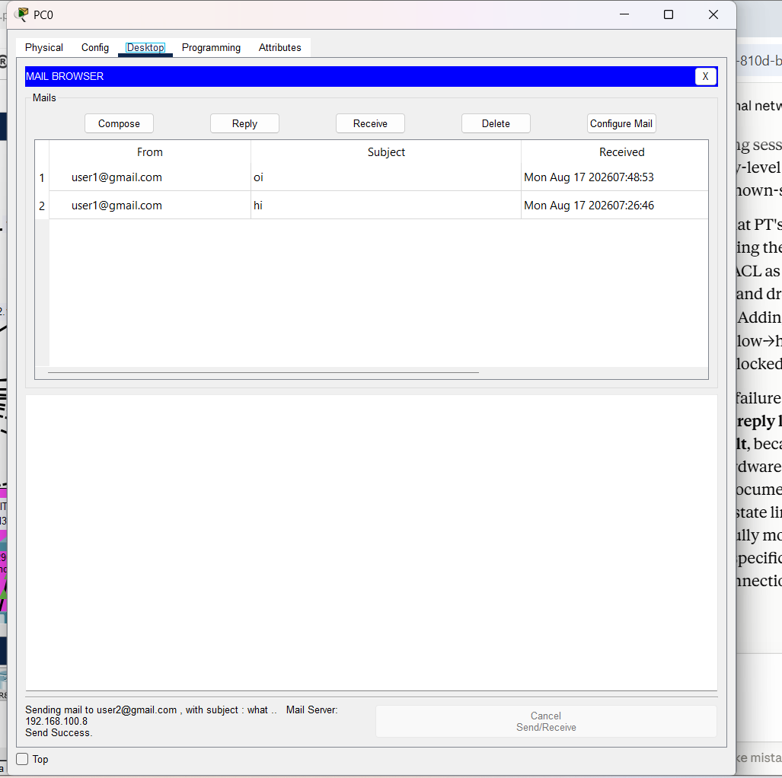
Success msg lets check from both internal side and from outside network internet side,
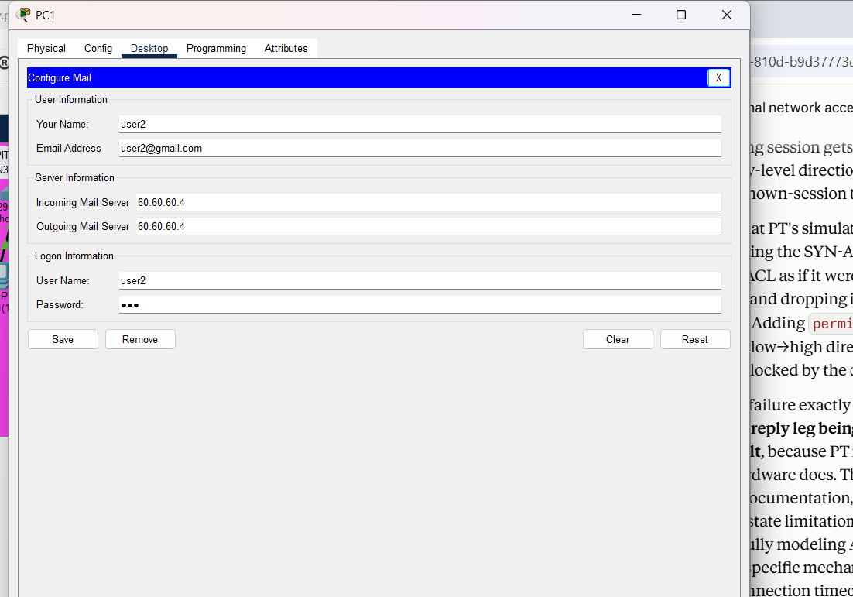
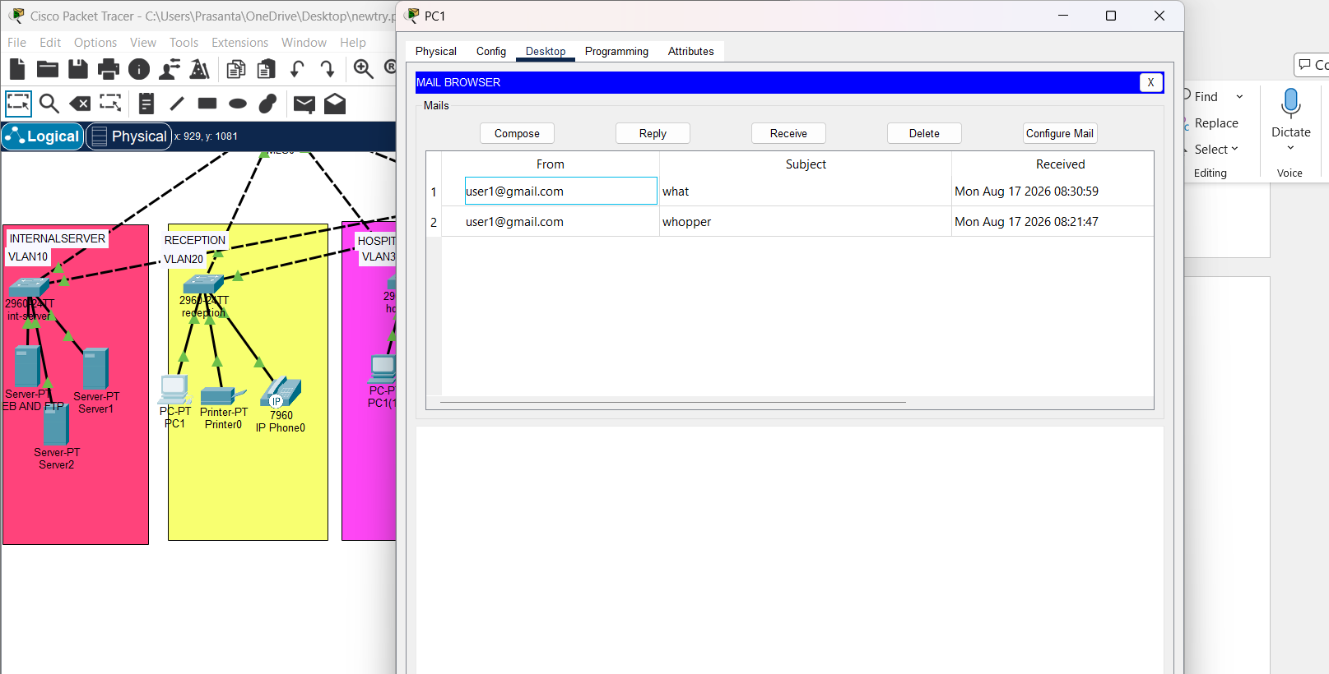
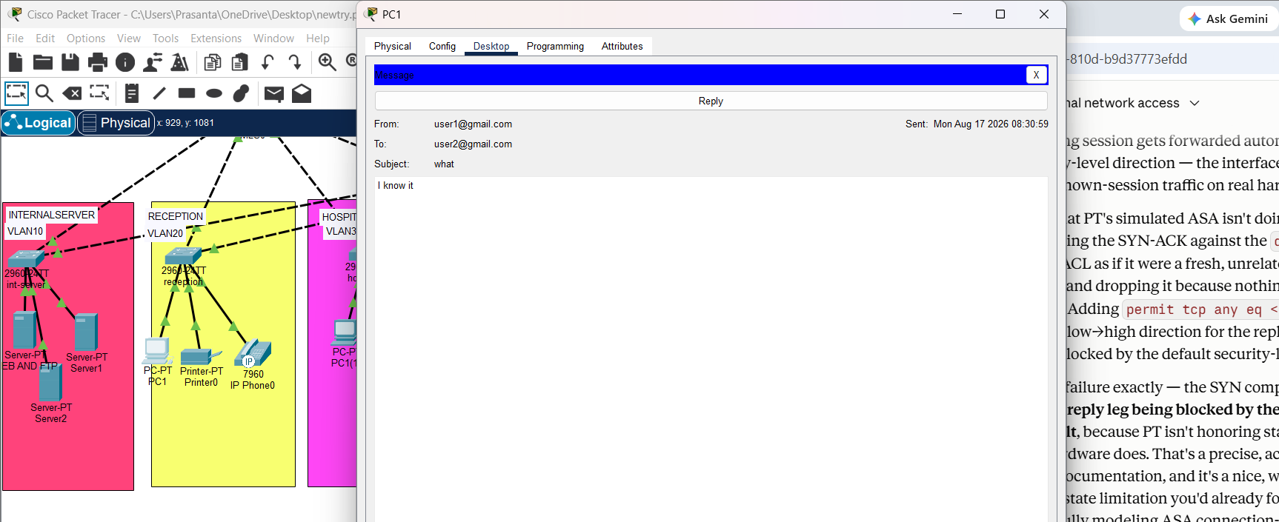Now lets check from internet side,
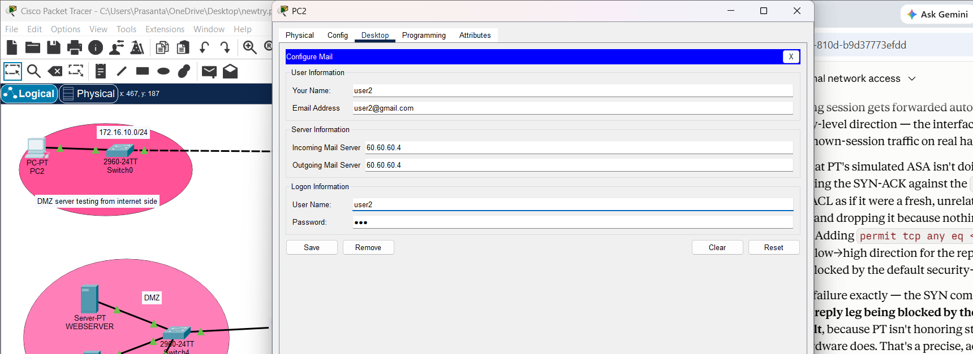
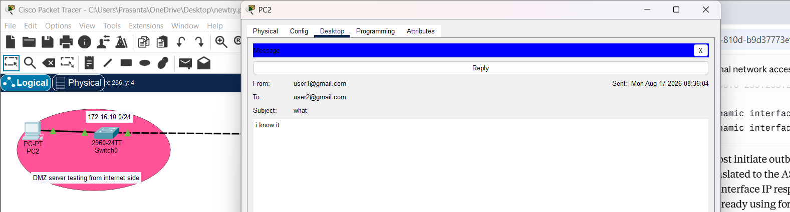
Done mail service works.

